Chapter 3: Cell Processes and Energy
Section 1: Chemical Compounds in Cells

Main Ideas

What are elements and compounds?  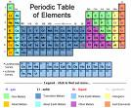 | An element is any substance that cannot be broken down into simpler substances.
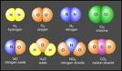 | A compound exists when two or more elements combine chemically to form a compound.
How is water important to the function of cells?  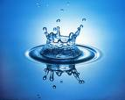  cells?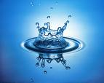  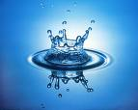 | Most chemical reactions within the cells could not take place without water.  Water also helps cells keep their size and shape.
The four main kinds of organic compounds in living things are: | Carbohydrates  Lipids  Proteins  Nucleic acids
Carbohydrates  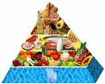 | Energy-rich organic compounds made of the elements carbon, hydrogen and oxygen.  Most compounds that contain carbon are known as organic compounds.  Carbohydrates are important components of some cell parts like the cell membrane.
Lipids | Lipids: Energy-rich organic compounds made of carbon, hydrogen, and oxygen.  Cells store energy in the form of lipids for later use.  They contain even more energy than carbohydrates.
Proteins  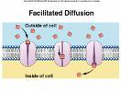  Amino Acids  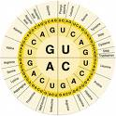  Enzymes  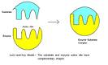 | Large organic molecules made of carbon, hydrogen, oxygen, nitrogen, and in some cases, sulfur.  In this picture transport proteins are moving material across the cell membrane.  Proteins:- form parts of the cell membrane  - make up many of the organelles  Protein molecules are made up of these smaller molecules. The arrangement of these amino acids can result in many proteins.  A type of protein that speeds up chemical reactions in a living thing.  Enzymes in saliva speed up digestion by breaking down foods in your mouth.
Nucleic Acids  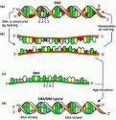  DNA  (Deoxyribonucleic acid)  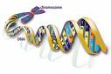 | Nucleic acids are very long chain molecules made of carbon, oxygen, hydrogen, nitrogen, and phosphorous.  They contain the instructions that cells need to carry out all the functions of life.  The genetic material that carries information about an organism and is passed from parent to offspring.  It also directs all the cell’s functions.
Chromatin  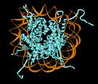  RNA  (Ribonucleic Acid)  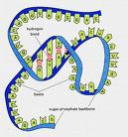 | Most of the DNA in a cell is found in the chromatin in the nucleus.  Plays an important role in the production of proteins. It is found in both the nucleus and the cytoplasm.

