Chapter 3: Cell Processes and Energy
Section 5: Cell Division

Main Ideas

What events take place during the three stages of the cell cycle?  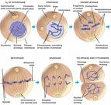 | Stage 1: The cell grows, makes a copy of its DNA, and prepares to divide.  Stage 2: One copy of the DNA is distributed into each of the two daughter cells.  Stage 3: The cytoplasm divides. The organelles are distributed into each of the two new cells.
How does the structure of DNA help account for the way in which DNA copies itself?  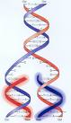 | DNA molecules look like a twisted ladder.  The two sides of the ladder are made up of a sugar known as deoxyribose and molecules known as phosphates.  Each step on the ladder are made up of molecules called nitrogen bases.  DNA has only four kinds of nitrogen bases;  Adenine which always pairs with Thymine  Guanine always pairs with Cytosine.  A-T G-C  Because of the way in which the nitrogen bases pair with one another, the order of the bases in each new DNA molecule exactly matches the order in the original DNA molecule.

Key Terms
Cell cycle  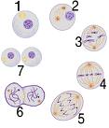 | The regular sequence of growth and division that cells undergo is known as the cell cycle.
Interphase  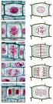 | Stage 1 of the cell cycle.  The cell grows, makes a copy of its DNA, and prepares to divide into two cells.
Replication  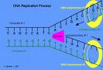 | The cell makes an exact copy of the DNA in its nucleus.
Mitosis  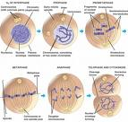 | Stage 2 of the cell cycle.  One copy of the DNA is distributed into each of the two daughter cells.
Chromosome  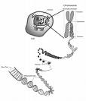 | During prophase, the threadlike chromatin in the nucleus condenses to form double rod structures called chromosomes.

Cytokinesis  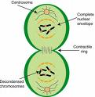 | The cytoplasm divides and the organelles are distributed into each of the two new cells.
Cytokinesis in Animal Cells  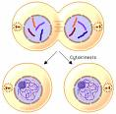 | The cell membrane squeezes together around the middle of the cell. Then pinches off into two cells.
Cytokinesis in Plant Cells  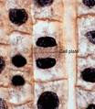 | A cell plate forms across the middle of the cell which gradually develop into new cell membranes between the two new cells. New cell walls gradually form around the cell membranes.
The Cell Cycle  Interphase  Stage 1  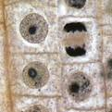 | The cell grows to its mature size, makes a copy of its DNA, and prepares to divide.  The centriole is also copied.
Mitosis  Stage 2  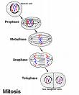  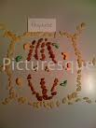 | Prophase: Chromatin in the nucleus condenses to form chromosomes. The pairs of centrioles move to opposite sides of the nucleus . Spindle fibers form a bridge between the ends of the cell. The nuclear envelope breaks down.

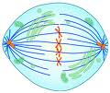 | Metaphase: The chromosomes line up across the center of the cell. Each chromosome attaches to a spindle fiber at its Centro mere.
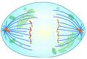 | Anaphase: The centromeres split. The two chromatids separate. One chromatid is drawn by its spindle fiber to one end of the cell. The other chromatid moves to the opposite end. The cell stretches out as the opposite ends are pushed apart.
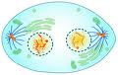  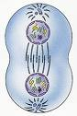 | Telophase: The chromosomes begin to stretch out an lose their rodlike appearance. A new nuclear envelope forms around each region of chromosomes.

Cytokinesis  Stage 3  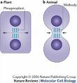 | The cell membrane pinches in around the middle of the cell. The cell splits in two. Each daughter cell ends up with an identical set of chromosomes and about half the organelles.

