Chapter 16: Circulation
Section 1: The Body’s Transport System
Pages 534-543

Main Ideas
What are the functions of the cardiovascular system?  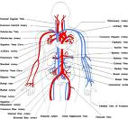 | - Carries needed substances to cells  - Carries off waste products  - Contains cells that fight off disease
What is the function and structure of the heart?  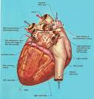  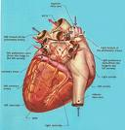 | - The heart pushes blood through the blood vessels of the cardiovascular system.  - The right side of the heart is completely separated from the left side of the heart by a wall of tissue called the septum. Each side has two compartments, an upper and a lower chamber.
What path does blood take through the cardiovascular system?  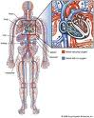 | Two loops  - Loop One: In the first loop, blood travels from the heart to the lungs and then back to the heart.  - Loop two: In this loop, blood is pumped from the heart throughout the body and then returns again to the heart.

What are the functions and structures of arteries, capillaries, veins | - Artery walls are very thick, they consist of three layers of cells. When blood leaves the heart it travels through arteries.  - Capillaries are only one cell thick. They are the blood vessels where diffusion of needed materials occurs.  - Veins walls are also three cells thick. They return blood to the heart.
Key Terms
Cardiovascular system  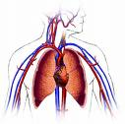 | A system that carries needed substances like oxygen and nutrients to the cells, and carries waste, like carbon dioxide and other materials away from the cells.  Blood also contains cells that fight disease.
Heart  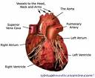 | A hollow muscular organ that pumps blood throughout the body. Each time it beats, it pushes blood through the blood vessels of the cardiovascular system.
Atrium  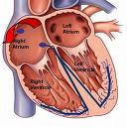 | The atrium receives blood that comes into the heart.  Right atrium receives oxygen poor blood  Left atrium receives oxygen rich blood

Pacemaker  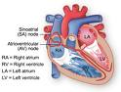 | Located in the right atrium, the pacemaker is a group of heart cells which sends out signals that make the heart muscles contract.
Ventricle  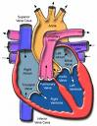 | The right ventricle is the lower chamber that receives oxygen poor blood from the right atrium and pumps blood to the lungs.  The left ventricle receives oxygen rich blood from the left atrium that has returned from the lungs and pumps it to the rest of the body.
Valve  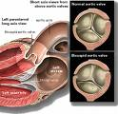 | A flap of tissue that prevents blood from flowing backwards. Valves are located between the atria and the ventricles. They are also located between the ventricles and the arteries that carry blood away from the heart.  Valves are also located in your arms and legs.
Artery  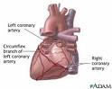 | Blood vessels that carry blood away from the heart. They are three cells thick and very strong.
Capillary  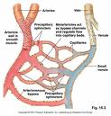 | From the arteries, blood flows into tiny, narrow blood vessels called capillaries. In the capillaries substances are exchanged between blood and body cells (mostly through diffusion). They are one cell thick and very delicate.

Vein  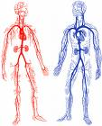 | From capillaries, blood flows into the veins, blood vessels that carry blood back to the heart.  Veins are also three cells thick.
Aorta  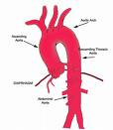 | The artery located at the top of the heart that is the largest artery in the body. Blood is pumped from the left ventricle into the aorta. It distributes blood to other major arteries along the way.
Coronary artery  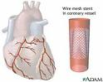 | Coronary arteries are the first branches off the aorta. They supply blood to the heart itself.
Pulse  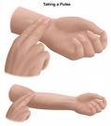 | The alternating expansion and relaxation of the artery wall that occur with every heartbeat.

Diffusion  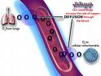 | The process by which molecules move from an area of higher concentration to an area of lower concentration.
Blood pressure  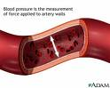 | The force that blood exerts against the walls of the blood vessels

