Name: ________________________________ Block: _______________

Chapter 1 Section 2: Scientific Inquiry

Main Ideas

1. Scientific inquiry refers to the many ways that scientists study the natural world and make explanations based on the evidence they gather.

2. A hypothesis is testable so that researchers can carry out investigations and gather evidence to either support or disprove the hypothesis. | 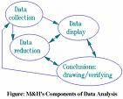
3. Scientific attitudes, or habits of the mind, include curiosity, honesty, open-mindedness, skepticism, and creativity. | 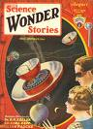
Scientific inquiry | ?????  ???????  ????????? | The many different ways that scientists study the world and explain the information using the evidence that they collect.
Hypothesis | 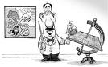 | A possible explanation for a set of observations or an answer to a scientific question.
Variable | 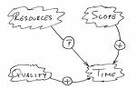 | A factor that can change in an experiment
Controlled Experiment | 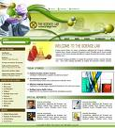 | An experiment in which only one variable is manipulated at a time.
Manipulated variable | 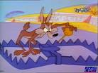 | The one variable that is purposely changed to test a hypothesis is called the manipulated variable.  AKA independent variable
Responding variable |  | The factor that may change in response to the manipulated variable.  AKA dependent variable
Operational definition | 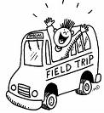 | A statement that describes how to measure a variable or define a term.  Example: What is a scream on a bus?
Data | 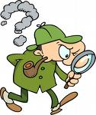 | The facts, figures, and other evidence gathered through observations.  Data tables organize information collected. Graphs can help interpret information.
Communicating | 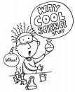 | The sharing of ideas and experimental findings with others through writing and speaking.

