Chapter 2: Section 3
Discovering Cells

Main Ideas
What are cells?  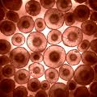  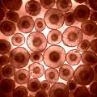 | Cells are the basic units of structure and function in living things. That means that they are the smallest piece of living material.
How did the invention of the microscope help scientists learn more about living things? | The invention of the microscope made it possible for people to discover and learn about cells.  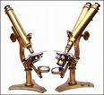
What is the cell theory? | It is a widely accepted explanation of the relationship between cells and living things.  What does this mean?  - All living things are composed of cells.  - Cells are the basic units of structure and function in living things.  - All cells are produced from other cells.
How do microscopes produce magnified images? | The lenses in light microscopes magnify an object by bending the light that passes through them.  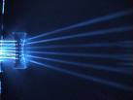
 | Invisibility cloaks may be a bit closer to reality, researchers say, thanks to the development of two new materials that are the first to bend visible light the "wrong" way in three dimensions. The so-called metamaterials are artificial composites designed to manipulate light in ways that natural materials can't—in these cases by refracting it backward. (Related: "The Power of Light" in National Geographic magazine.)
Key Terms
Cell  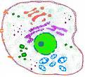 | The basic unit of structure and function in living things.  - Cells are able to perform very specific tasks in a multi-cellular organism.  - Cells are able to complete all the requirements of a living thing as a one-celled organism.  - Life processes include obtaining oxygen, getting rid of waste, obtaining food, and growing.
Microscope  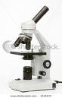 | A tool that allows scientists, and students, to examine organisms or tissues and cells that are too small to see with our eyes.  It makes small objects appear larger.  Like vorticella .  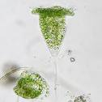
Cell theory  Prokaryotes lack a nucleus.  Eukaryotes have a nucleus.  The nucleus is the control center of the cell.  All processes in the cell are driven by the production of proteins in the nucleus of the cell. | A widely accepted explanation of the relationship between cells and living things.  Prokaryotes Eukaryotes  {Bacteria, Archea} {Protists, Plants,  Animals, Fungi}  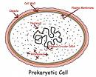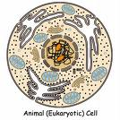
Compound light microscope  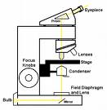 | Use more than one lens. An eyepiece and an objective lens are used.
Electron microscope  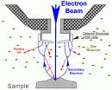 | Use a beam of electrons instead of light to produce a magnified image. The resolution is incredible relative to the compound light microscope.  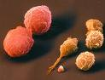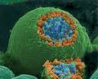
Extra notes:

