Chapter 3: Cell Processes and Energy
Section 3: Photosynthesis
Pages 86-90

Main Ideas

How does the sun supply living things with the energy they need?  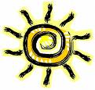 | Light energy from the sun is used to chemically combine the elements carbon, hydrogen and oxygen into sugars.  (Remember all the organic compounds in the last section were composed, or made up of carbon, hydrogen and oxygen!)
What happens during the process of photosynthesis?  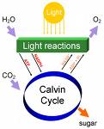 | Photosynthesis is divided into two stages.  Stage 1: Chloroplasts in plant cells capture  the energy from sunlight.  Stage 2: The captured light energy is used to  convert carbon dioxide and water  into sugars and oxygen through a  series of complex chemical  reactions.

Key Terms

Photosynthesis  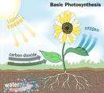 | The process by which a cell  captures energy in sunlight and uses it to make food.  Nearly all living things get their energy either directly or indirectly from the energy of sunlight captured during photosynthesis.
Autotroph  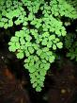 | An organism that can make its own food.  Remember auto=self and troph=feeder.  These are also known as producers.

Heterotroph | An organism that cannot make its own food. Many heterotrophy obtain the energy they need by eating other organisms.  These are also known as consumers.

Pigments  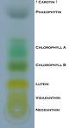 | Colored chemical compounds that absorb light. Most of the time it is green.
Chlorophyll  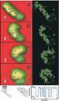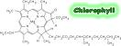 | The main photosynthetic pigment in chloroplasts.  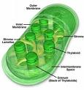
Stomata  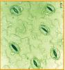 | Small openings on the undersides of leaves through which carbon dioxide enters the plants.  In warmer weather these openings also allow water to escape from the plant through a process called transpiration.
The Photosynthesis Equation | 6CO + 6H O -------- C H O + 6O  It is the inverse of the Respiration Equation.

