Chapter 3: Cell Processes and Energy
Section 4: Respiration
Pages 91 to 94

Main Ideas

What events occur during respiration?  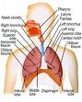  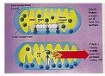 | During respiration, cells break down simple food molecules such as sugar and release the energy they contain.  Respiration has two meanings:  1. Breathing brings air into and out of  the lungs.  2. Respiration takes place inside the  cells and is called cellular respiration.
What is fermentation?  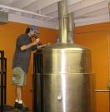 | An energy-releasing process that does not require oxygen.

Key Terms

Respiration  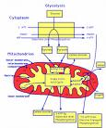 | The process by which cells obtain energy  from glucose.  There are two stages of respiration:  Stage 1: In the cytoplasm of the  organism’s cells molecules of  glucose are broken down into  smaller molecules. Oxygen is not  involved and only a small mount  of energy is released  Stage 2: In the mitochondria small  molecules are broken down into  even smaller molecules. This  process requires oxygen and  releases a great deal of energy.  Mitochondria = power house of the cell  S
Respiration equation  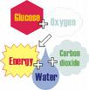 | C H O + 6O -----6CO + 6H O = energy  Notice that the respiration equation is the inverse of the photosynthetic equation.
Fermentation | Provides energy for cells without using oxygen.  It releases much less energy than cellular respiration.
Alcoholic fermentation  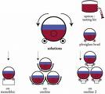 | When yeast and some other single-celled organisms break down sugars. Alcohol is one of the products. This is important to bakers and brewers who depend on such anaerobic processes.
Lactic Acid Fermentation  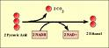 | This is due to hard exercise. When an athlete’s muscles run out of oxygen fermentation occurs. This will supply your body cells with energy. One product of this type of reaction is lactic acid.  This causes muscle cramping and soreness.

