Name: ________________________________ Block: __________

Chapter 1 section 4: Safety in the Science Laboratory

Main Ideas  Good preparation helps you stay safe when doing science activities. | 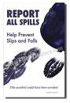 | I have my safety goggles  on so I think that my eyes  are protected from glass.  I do not eat in the lab and  thus am safe from ingest-  ing amoebic dysentery!
If any accident occurs, no matter how minor, notify your teacher immediately. Then listen to your teachers  directions and carry them out quickly. | 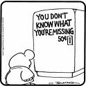 | Use your skills in  assessing situations.  If it seems like something  is wrong…it is!
Preparing for a lab activity means that you are doing a pre-lab write-up.  Becoming familiar with the  Lab procedure and instructions before attempting to complete the lab activity. | 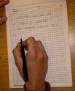 | Preparing any data tables  or other data recording  charts necessary before  working on the lab.
End-of-Lab Procedures |  | Turn off, unplug and  dispose of waste. Return  materials and equipment  to its proper place.
Safety in the Field…..  Watch out for severe weather, wild animals, and poisonous plants. | 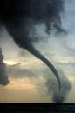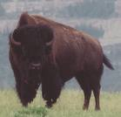 | Ticks  Mountain lions  Beavers  Skunks  Bids of prey  Unruly children!  On occasion,  Bison. Don’t forget  The poison ivy!

