Chapter 3: Cell Processes and Energy
Section 2: The Cell in Its Environment

Main Ideas

How do most small molecules cross the cell membrane?  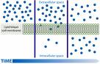 | Diffusion is the main method by which small molecules move across the cell membrane.  Diffusion is the process by which molecules move from an area of higher concentration to an area of lower concentration.  Molecules are always moving, bumping into each other. The more molecules there are in an area, the more bumping there will be. These cause the molecules to spread out evenly through the area.  In diffusion, molecules move through a selectively permeable membrane.
Why is osmosis important to cells?  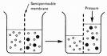 | Osmosis is important to cells because cells cannot function properly without adequate water. Many cellular processes depend on osmosis.  In osmosis, WATER MOLECULES move by diffusion from an area where they are highly concentrated through a cell membrane to an area where they are less concentrated.  In osmosis, water diffuses through a selectively permeable membrane.
What is the difference between passive transport and active transport?  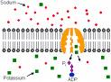 | Passive transport is the movement of dissolved materials through a cell membrane without using cellular energy.  Active transport is the movement of materials through a cell membrane using cellular energy.  Active transport requires the cell to use its own energy, while passive transport does not.
Transport proteins  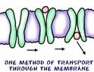 | Transport proteins can change their shape to pick up molecules outside the cell and carry them in, using energy.  Transport proteins can change their shape to carry molecules out of the cell, using energy.
Transporting by Engulfing  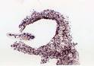 | The cell membrane surrounds and engulfs, or encloses, a particle. Once the particle is engulfed, the cell membrane wraps around the particle and forms a vacuole within the cell. The cell uses energy in this process but will benefit by the energy that will be provided when needed.
Selectively permeable  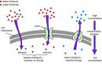 | Some substances can pass through the membrane while others cannot. Like a screen on a window.

