Chapter 2 Section 4
Looking Inside Cells

Main Ideas
What is the role of the cell wall?  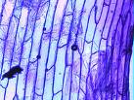 | It helps protect and support the cell.
What is the role of the cell membrane?  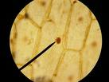 | It controls what substances come into and out of a cell.
What are the functions of the cell’s organelles?  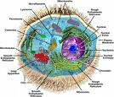 | Each organelle carries out a specific function within the cell.  Just as organ systems in your body have different functions or responsibilities each organelle has a different function or responsibility.
How are cells organized in many celled organisms?  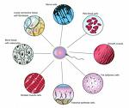 | In many celled organisms, cells are organized into single cells,  tissues, organs, organ system, and organisms.
Key Terms
Organelles  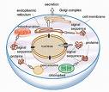 | Carry out specific functions within the cell. These are even smaller structures inside the cell.
Cell wall  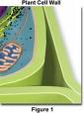 | A rigid layer of nonliving material that surrounds the cells of plants and some other organisms. (Animal cells son not have a cell wall.) A cell wall helps to protect and support the cell. (Composed or cellulose.)
Cell membrane  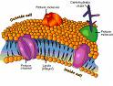 | Located inside the cell wall (in organisms with a cell wall.) In other cells, the cell membrane forms the outside boundary that separates the cell from it’s environment.  It controls what substances come into and out of the cell.
Nucleus  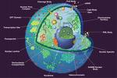 | The cell’s control center, directing all of the cell’s activities.
Nuclear envelope  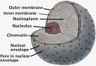 | The membrane that surrounds the nucleus. It protects the nucleus.
Chromatin  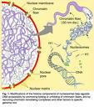 | Contains genetic material, the instructions for directing the cell’s functions.
Nucleolus  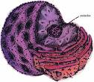 | The structure where ribosomes are made.
Cytoplasm  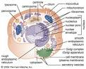 | The clear, thick, gel-like fluid between the cell membrane and the nucleus. It is constantly moving
Mitochondria  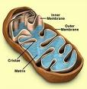 | The “powerhouse of the cell” because mitochondria convert energy in food molecules to energy the cell can use to carry out it’s functions.
Endoplasmic reticulum  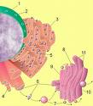 | The passageways that carry proteins and other materials from one part of the cell to another.
Ribosome  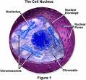 | Some are attached to the endoplasmic reticulum. Some float in the cytoplasm.  They are small, grain-like bodies that function as factories to produce proteins.
Golgi body  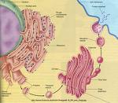 | Receive proteins and other newly formed materials from the endoplasmic reticulum. Package them, and distribute them to other parts of the cell.
Chloroplast  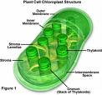 | Capture energy from the sunlight and use it to produce food for the cell.
Vacuole  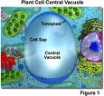 | Large storage areas of the cells, usually storing water, or food, (or possibly wastes).
Lysosome  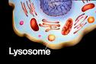 | Small, round structures containing chemicals that break down certain materials in the cell. They are the “cell’s clean-up crew”

