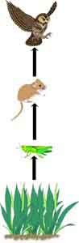  FOOD CHAIN  (just one path of energy) | 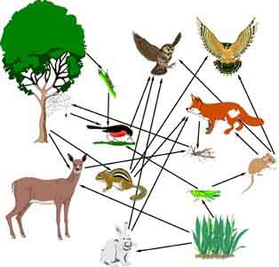  FOOD WEB  (everything is connected!)

