Gillen D’Arcy Wood, “1816, The Year without a Summer”

Abstract
The so-called “Year Without a Summer”—1816—belongs to a three-year period of severe climate deterioration of global scope caused by the eruption of Mt. Tambora in Indonesia in April, 1815. With plummeting temperatures, and disruption to major weather systems, human communities across the globe faced crop failures, epidemic disease, and civil unrest on a catastrophic scale. In cultural terms, the dreary summer of 1816 is best known as the setting for Mary Shelley’s writing of Frankenstein, a novel whose iconic Creature offers a figure for the millions of hungry and dispossessed of Europe during the protracted climate emergency that followed Tambora’s eruption.
Download this page in PDF format
To be alive in the years 1816-18, almost anywhere in the world, meant to be hungry. Across the globe during the so-called “Year Without a Summer”—which was, in fact, a three-year climate crisis—harvests perished in frost and drought or were washed away by flooding rains. Villagers in Vermont survived on hedgehogs and boiled nettles, while the peasants of Yunnan in China sucked on white clay. Summer tourists traveling in France mistook beggars crowding the roads for armies on the march. One such group of English tourists, at their lakeside villa near Geneva, passed the long, cold, crop-killing days by the fire writing ghost stories. Despite the fame of Mary Shelley’s novel Frankenstein—the signature literary production of the “Year Without a Summer”—the global scope of the climate emergency in the immediate post-Waterloo period remains little known.
1816 was a time when the overwhelming majority of the world’s population depended on subsistence agriculture, living precariously from harvest to harvest. When the crops failed that year, and again the next, starving rural legions from China to Ireland swarmed out of the countryside to market towns to beg for alms or sell their children in exchange for food. Famine-friendly diseases cholera and typhus stalked the globe from India to Italy, while the price of bread and rice, the world’s staple foods, skyrocketed with no relief in sight. Across a European continent devastated by the Napoleonic wars, tens of thousands of unemployed veterans found themselves unable to feed their families. They gave vent to their desperation in town square riots and military-style campaigns of arson, while governments everywhere feared revolution. In New England, 1816 was nicknamed “Eighteen-Hundred-and-Froze-to-Death,” while Germans called 1817 “The Year of the Beggar.” In terms of its enduring presence in folklore, as well as its status in the scientific literature, 1816’s cold summer was the most significant meteorological event of the nineteenth century. The global climate emergency period of 1816-18, as a whole, offers us a clear window onto a world convulsed by weather anomalies, with human communities everywhere struggling to adapt to sudden, radical shifts in weather patterns, and to a consequent tsunami of famine, disease, dislocation and unrest.
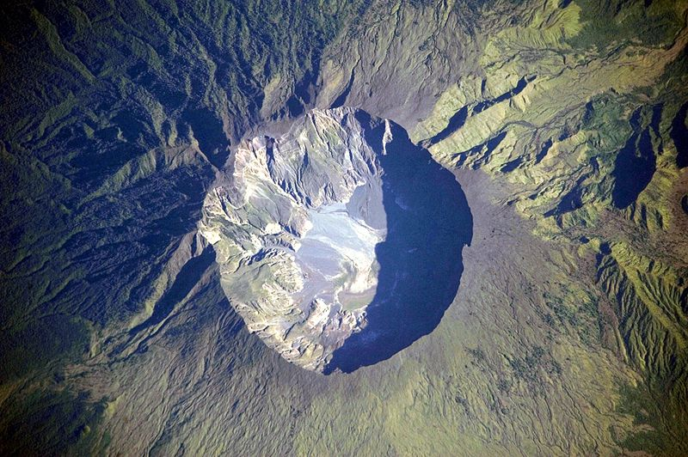
The Summit Caldera of Mount Tambora
Why did the global climate deteriorate so abruptly in 1815-18 before returning, just as suddenly, to its prior relative equilibrium? The answer lies in a major geological event that occurred half-a-world away from Europe and North America. The massive eruption of Mt. Tambora on the island of Sumbawa in the Dutch East Indies (now Indonesia) on 10 April 1815 is the most explosive volcanic event in the historical record, and among the largest eruptions of the last 10,000 years on Earth. Mt. Tambora’s explosion thrust plumes of gas and ash some 43km into the stratosphere—with fallout distributed as far as 1300km distant—and plunged the entire East Indian region into darkness. The massive load of sulfate gases Tambora injected into the stratosphere produced an aerial dust cloud consisting of up to 100 cubic kilometers of debris. This great sun-obscuring plume then circled the earth at the equator in a matter of weeks before drifting pole-ward, playing havoc with the world’s major weather systems for almost three years. The eruption itself had a devastating immediate impact on the East Indian region: its 90,000 deaths is the highest mortality of any known volcanic event. But Tambora’s three-year disruption of the global climate system—including a fall in average temperatures between 3°F and 6°F and severe disruptions in seasonal precipitation—spelled disaster on much larger scales for pre-industrial human communities worldwide, including the relatively advanced economies of the transatlantic region.
A brief and incomplete summary of Tambora’s historical impacts would include the following: first, by weakening the European colonial administration and creating a years-long food crisis for the local population, the Tambora disaster altered the political balance of power in South-East Asia, strengthening the indigenous systems of piracy and slavery against westernizing influences. Beyond ground zero, Tambora’s sulfate dust veil disrupted the South Asian monsoons for three consecutive years, a sustained weather crisis that created conditions for the birth of modern, epidemic cholera in Bengal in 1817, which gradually spread across the globe in the nineteenth century, killing millions. Across the mountains in southwest China, imperial control weakened during the famines of the Tambora period, spawning ethnic rebellion against the Qing Dynasty, and allowing the opium trade to flourish in the narco-state of Yunnan, which later became the global center of poppy production.
Meanwhile, across the hemispheric divide in Western Europe, some hundreds of thousands perished from hunger and disease, while great waves of rural environmental refugees, driven from their homes by Tamboran weather, invaded the cities or headed east to Russia and west to America. Further north, volcanic winter warming between 1815 and 1818 melted the Arctic icepack, prompting the first race of nations to the North Pole. The exploits of Kotzebue, Parry, and Franklin launched arctic exploration as a defining cultural fantasy of the nineteenth century. Finally, in the United States, 1816 produced the only recorded instance of zero tree growth, deducible from the missing ring in the oak trees of the North-East. Farmers there suffered their shortest ever growing season, interrupted by brutal summer frosts, and left New England in droves for the promised lands of Ohio and Pennsylvania, while the infant, frontier Midwest seized the moment to secure a position as a major agricultural producer for the nation and the Atlantic world.
As the foregoing sketch suggests, a global history of the Tambora event is dizzying in scale and difficult to articulate in conventional historiographical terms. Indeed, the full ecological dimensions of Tambora have only become apparent since the 1980s, due to advances in the data-gathering techniques of paleoclimatologists. Since then, the claims for Tambora’s geo-historical importance have grown more compelling with the publication of every research paper detailing the uniquely loud climate signal of 1816, recorded everywhere from the ice shelves of the Antarctic to the forests of New England.
The global Tambora event offers a compelling backdrop to the well-known histories of Romantic literary production in the immediate post-Waterloo period, especially that of the Shelley circle. The bad weather of the summer months in 1816 is a touchstone of Mary Shelley’s correspondence. In a letter to her half-sister Fanny Imlay, written on her arrival in Geneva, Mary describes—in hair-raising language that would soon find its way into Frankenstein—their ascent of the Alps “amidst a violent storm of wind and rain” (Letters 1:17). The cold was “excessive” and the villagers they met complained of the lateness of the spring. On their alpine descent days later, an unseasonal snowstorm ruined their view of Geneva and its famous lake. In her reply, Fanny expresses her sympathy for Mary’s bad luck, reporting that it was “dreadfully dreary and rainy” in England, too, and very cold. (Kingston Stocking 1:48) Mary’s famous second letter to Fanny is one of the most vivid documents we have of the crazed volcanic weather during the summer of 1816: “An almost perpetual rain confines us principally to the house,” Mary wrote on the first of June from the shores of Lake Geneva. “One night we enjoyed a finer storm than I had ever before beheld. The lake was lit up—the pines on Jura made visible, and all the scene illuminated for an instant, when a pitchy blackness succeeded, and the thunder came in frightful bursts over our heads amid the blackness” (Letters 1:20).
In 1816-17, the scale of human suffering in Switzerland was among the worst in Europe. 130 days of rain between April and September 1816 swelled the waters of Lake Geneva, flooding the city, while in the mountains the snow refused to melt (Post 21). When the crops failed, thousands died of starvation during continental Europe’s last ever famine, while the numbers of indigent homeless ran into the hundreds of thousands. Mortality in 1817 was over 50% higher than its already elevated rate in the war year 1815. Everywhere, desperate villagers resorted to a pitiful famine diet of “the most loathsome and unnatural foods—carcasses of dead animals, cattle fodder, leaves of nettles, swine food. . . .” (Post 128).
Widespread stress on food supplies sparked waves of violent social protest across the continent. Riots broke out in the East Anglian counties in England, home of the painter John Constable, as early as May 1816. Armed laborers bearing flags with the slogan “Bread or Blood” marched on the cathedral town of Ely, held its magistrates hostage, and fought a pitched battle against the militia. Constable, a Tory, was scandalized, and his idealized visions of both rural weather and rural labor in his 1816 paintings “The Wheatfield” and “Flatford Mill, ” when viewed through a Tamboran lens, appear as the pictorial manifesto of an embattled conservative. In March 1817, more than 10,000 demonstrated in Manchester, while in June, the so-called “Pentrich Revolution” involved plans to invade and occupy the city of Nottingham. The army was called in to quell similar disturbances in Scotland and Wales. In the face of this wave of crime and insurrection, provincial jails filled to overflowing across the kingdom. Scores of rioters were subsequently hanged or transported.

